Patient Tracker Analysis
Use Case Document


 | Prepared By / Last Updated By | Reviewed by | Approved By
Name | Amrutha CY
Role | Team Member | Team Member | Scrum Master
Signature
Date | 06/06/2019

Table of Contents
1.0 Introduction 3
1.1 Purpose & Scope of the document 3
1.2 Intended Audience 3
1.3 Use case ‘Admin Registration’ 3
1.3.1 Use case attributes 3
1.3.2 Use Case Diagram 4
1.3.3 Business Rules 4
1.3.4 UI Field Validations 5
1.4 Use case ‘Admin Login’ 6
1.4.1 Use case attributes 6
1.4.3 Business Rules 7
1.5 Use case ‘Clerk Display By Id’ 3
1.5.1 Use case attributes 3
1.5.2 Use Case Diagram 4
1.5.3 Business Rules 4
1.5.4 UI Field Validations 5
1.6 Use case ‘Clerk Display All Details’ 3
1.6.1 Use case attributes 3
1.6.2 Use Case Diagram 4
1.6.3 Business Rules 4
1.6.4 UI Field Validations 5
1.7 Use case ‘Clerk Registration’ 3
1.7.1 Use case attributes 3
1.7.2 Use Case Diagram 4
1.7.3 Business Rules 4
1.7.4 UI Field Validations 5
1.8 Use case ‘Doctor Display By Id’ 3
1.8.1 Use case attributes 3
1.8.2 Use Case Diagram 4
1.8.3 Business Rules 4
1.8.4 UI Field Validations 5
1.9 Use case ‘Doctor Display All Details’ 3
1.9.1 Use case attributes 3
1.9.2 Use Case Diagram 4
1.9.3 Business Rules 4
1.9.4 UI Field Validations 5
1.10 Use case ‘Doctor Registration’ 3
1.10.1 Use case attributes 3
1.10.2 Use Case Diagram 4
1.10.3 Business Rules 4
1.10.4 UI Field Validations 5
1.11 Use case ‘Patient Display By Id’ 3
1.11.1 Use case attributes 3
1.11.2 Use Case Diagram 4
1.11.3 Business Rules 4
1.11.4 UI Field Validations 5
1.12 Use case ‘Patient Display All Details’ 3
1.12.1 Use case attributes 3
1.12.2 Use Case Diagram 4
1.12.3 Business Rules 4
1.12.4 UI Field Validations 5
1.13 Use case ‘Patient Registration’ 3
1.13.1 Use case attributes 3
1.13.2 Use Case Diagram 4
1.13.3 Business Rules 4
1.13.4 UI Field Validations 5
1.14 Use case ‘Medicine Display By Id’ 3
1.14.1 Use case attributes 3
1.14.2 Use Case Diagram 4
1.14.3 Business Rules 4
1.14.4 UI Field Validations 5
1.15 Use case ‘Medicine Display All Details’ 3
1.15.1 Use case attributes 3
1.15.2 Use Case Diagram 4
1.15.3 Business Rules 4
1.15.4 UI Field Validations 5
1.16 Use case ‘Medicine Registration’ 3
1.16.1 Use case attributes 3
1.16.2 Use Case Diagram 4
1.16.3 Business Rules 4
1.16.4 UI Field Validations 5
1.17 Use case ‘Create Prescription and Bill’ 3
1.17.1 Use case attributes 3
1.17.2 Use Case Diagram 4
1.17.3 Business Rules 4
1.17.4 UI Field Validations 5
2.0 Change Log 10

Introduction

Purpose & Scope of the document
The purpose of this Use case document is to systematically capture requirements for the project and the system to be developed in terms of use cases. Functional use cases are captured in this document. It also serves as the input for the project scoping.

The scope of this document is limited to addressing the use cases from a user, quality, and non-functional perspective.

Intended Audience
Each member of the project team

Use case ‘Admin Registration’

Use case attributes
Use Case Description:

This use case deals with the capture of user details. The ‘admin’ here shall be the operator of the system and will be keying in the required information into the system.

Scope:

- Admin registration

Actors:

- Admin – the operator

Trigger:

Click ‘Register’ button in the ‘User Registration’ page

Pre-Condition:

User being able to access the homepage & get redirected to the ‘Admin Registration’ page upon click of “Register” link.

Post Condition:

User is in the enrollment page & submit details

Flow of Events:

User at homepage → Click ‘Register’ link if new → Admin is in the enrollment page → Admin details are submitted and added onto the database

Primary Scenario:
A new user – is able to click ‘Register’ link and able to provide his details and get enrolled in the system.

Use Case Diagram
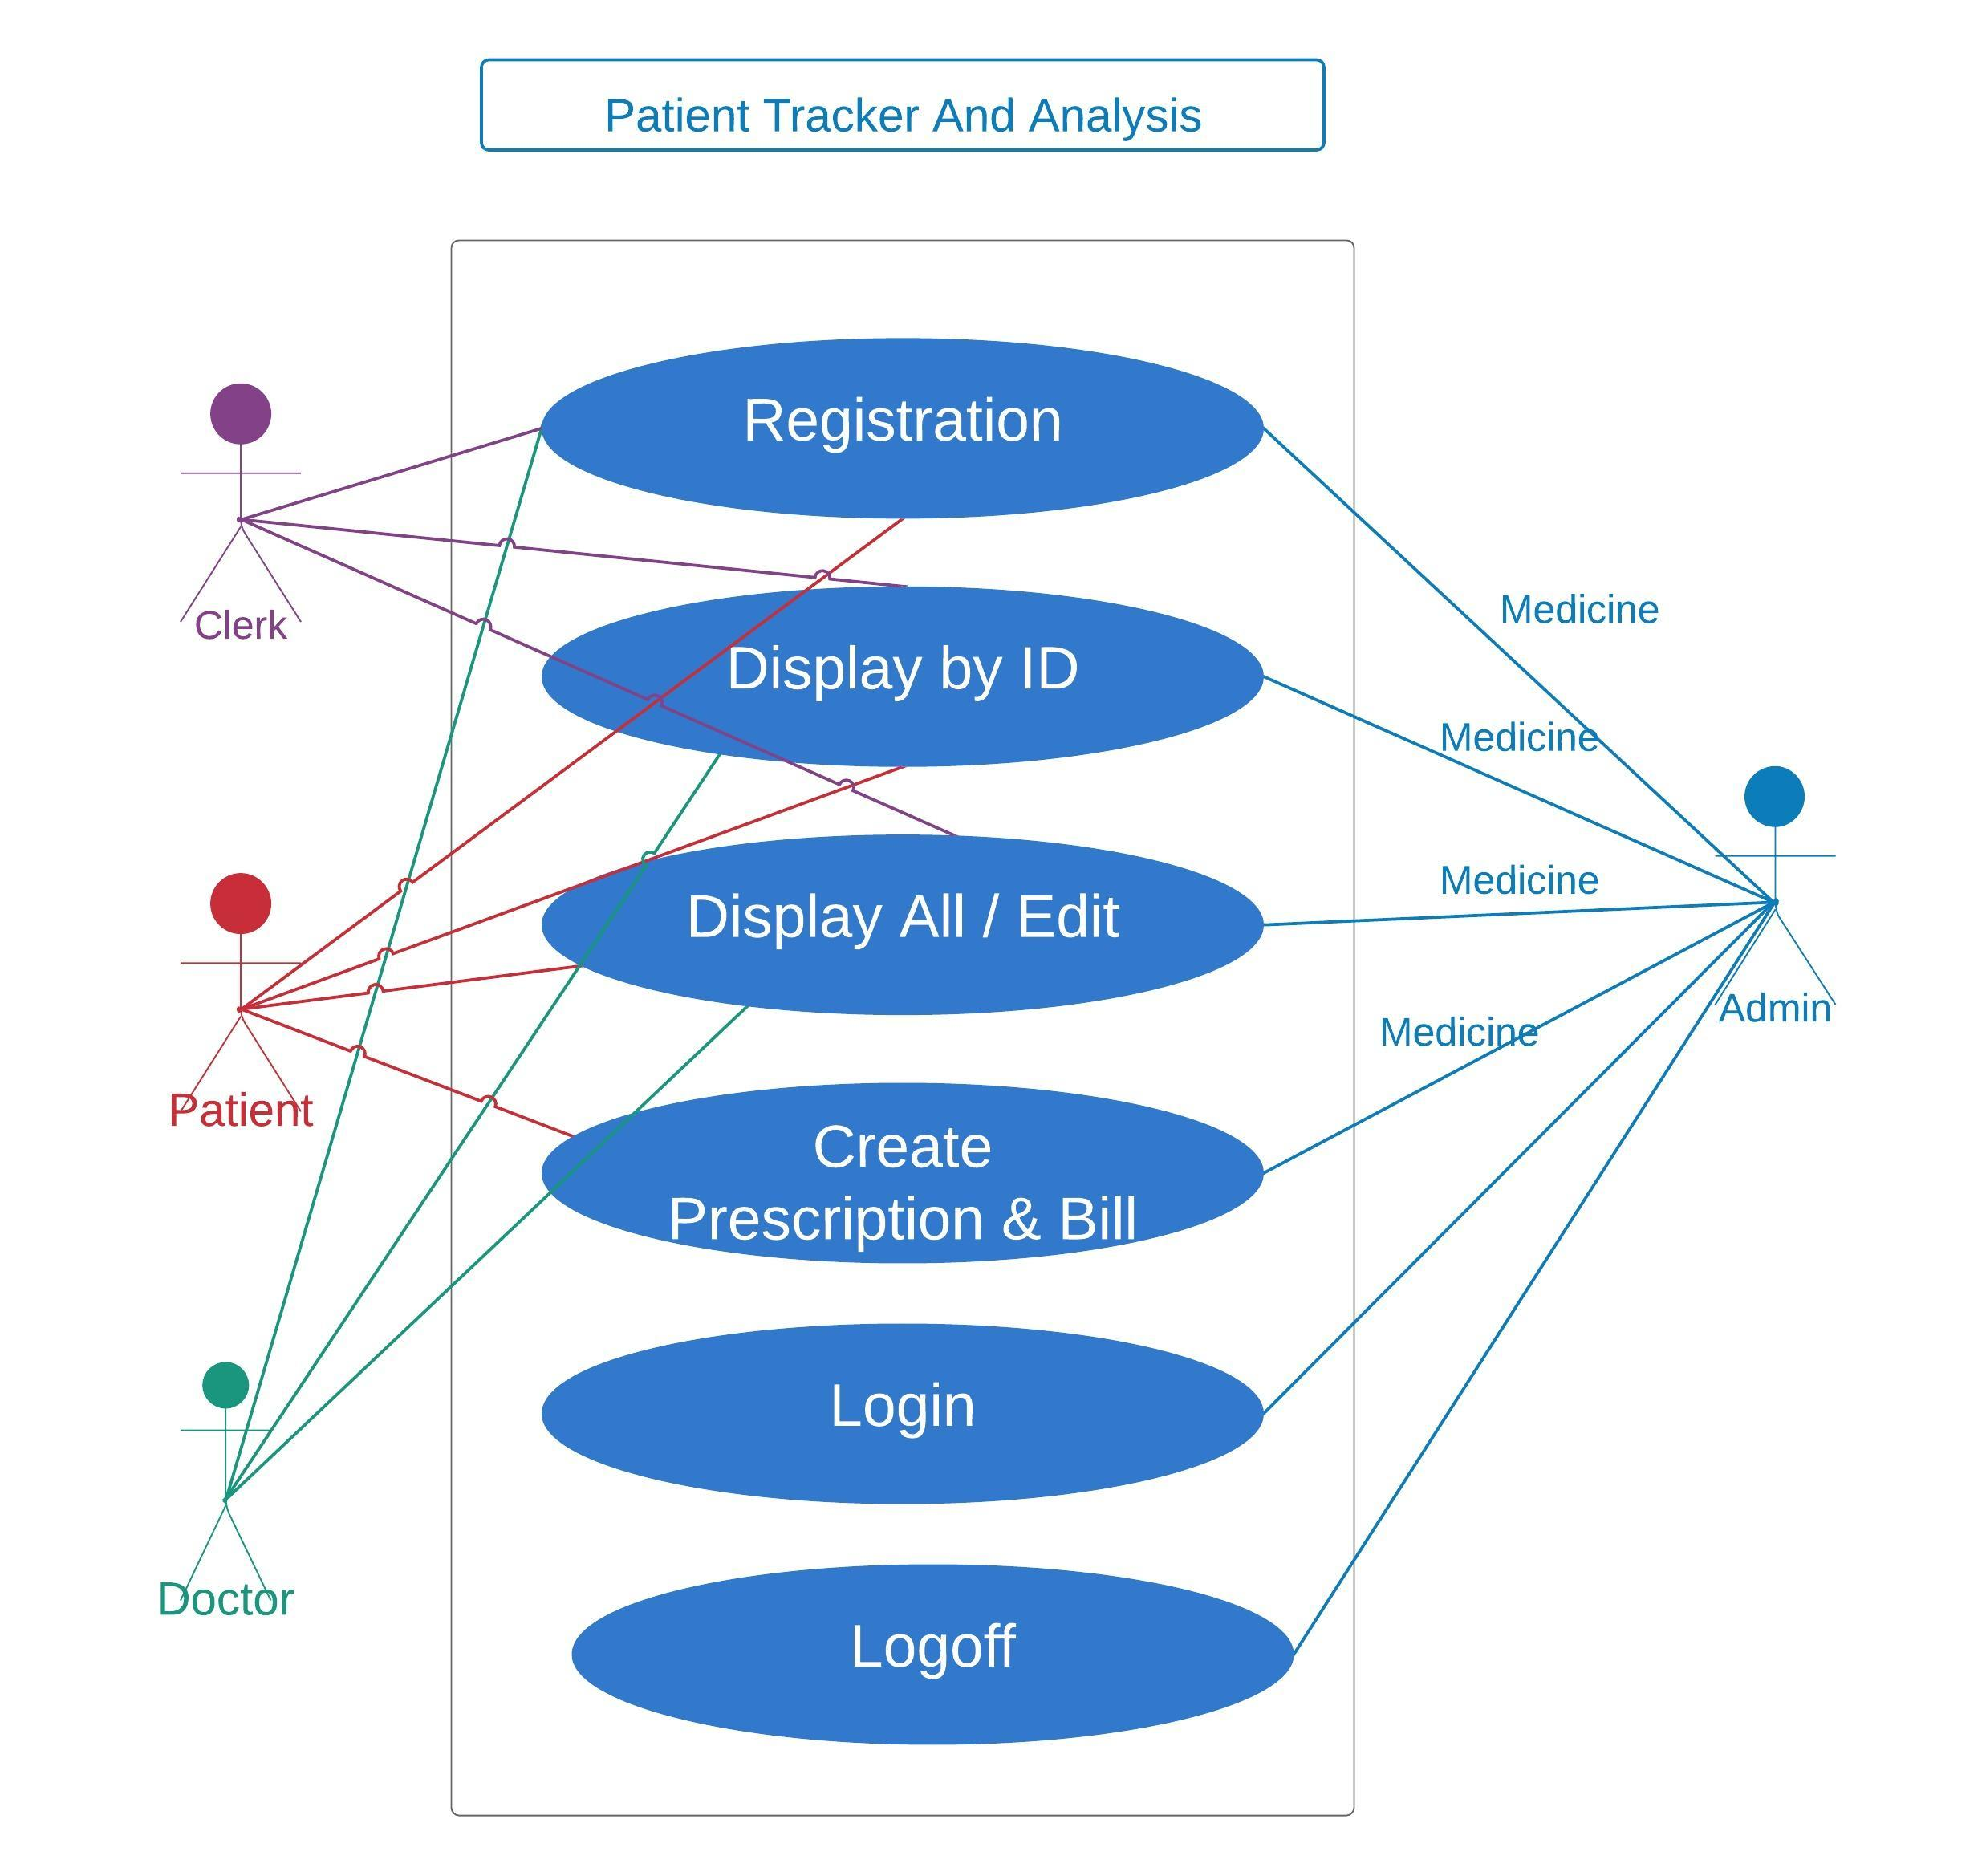

Business Rules

Business rules should be defined using the following attributes: -

- When the user clicks on the registration link, it should re-direct to registration form.
    - User needs to fill some of the basic attributes/fields as mentioned below in requirement: First Name, Last Name, Age, Gender, Contact Number, Alternate Contact number, Email ID, Password.
- Clicking ‘Register’ should validate the datatype constraints for each field
- Post-successful field level validation, save the information in the database
- Upon saving the information in the database, display the message ‘Your details are submitted successfully’.

UI Field Validations
Please refer to the below requirements for field level validations:

- All fields are mandatory except for alternate contact number.
- Username should be less than 30 chars. Password should have minimum 8 chars, no space & can contain special characters (ex.!,@,#,%,*,& etc.)
- Password and Confirm Password fields should be the same
- The Email ID format must be checked. (For ex. test@testmail.com.)
- Phone Number must be of 10 digits’ length

Use case ‘Admin Log in’

Use case attributes
Use Case Description:

This use case deals with the authentication of the user credentials. The ‘user’ here shall be the operator of the system and will be keying in the patient/doctor/clerk/medicine information into the system.

Scope:
Admin Log in
Actors:

User – the operator

Trigger:

Click ‘Login’ link, after keying in ‘AdminId’ & ‘Password’ field.

Pre-Condition:

User being able to access the homepage

Post Condition:

User is still in the home-page but now has the facility to view different tabs,i.e, Clerk, Doctor ,Patient ,Medicine, Prescription, Bill.

Flow of Events:

User at homepage → Key in ‘AdminId’ & ‘Password’ field → User credentials are validated → Home Page with all tabs to access all the fields.

Primary Scenario:
A registered user – is able click ‘Login’ link, after keying in ‘AdminId’ & ‘Password’ field and get his credentials authenticated with the existing database entry.

Alternative Scenario:
A registered user – is able click ‘Login’ link, after keying in ‘AdminId’ & ‘Password’ field and unable to get his credentials authenticated. The user is presented with relevant error messages:

- Invalid Admin ID or Password : Message will be given “Invalid Admin Id or Password”.

Business Rules
Business rules should be defined using the following attributes: -

- A registered user – is able click ‘Login’ link, after keying in ‘AdminId’ & ‘Password’ field and get his credentials authenticated with the existing database entry.

Use case ‘Clerk Display By Id’

Use case attributes
Use Case Description:

This use case deals with the fetching of the clerk details. The ‘admin’ here shall be the operator of the system and will be keying in the required information into the system.

Scope:

- Clerk Display By Id

Actors:

- Admin – the operator

Trigger:

Click ‘Clerk’ button in the ‘Home’ page

Pre-Condition:

User being able to access the homepage & get redirected after the successful login.

Post Condition:

User can see all the clerk details present in the database and upon clicking a particular clerkId it would lead them to complete information about the clerk.
Flow of Events:

User at homepage → Click ‘id’ link for full details → Admin is in the page which displays complete information about the clerk. → If the individual details are closed, then it returns to fetching all details

Primary Scenario:
Initially the complete database is shown and on clicking the id shows individual record.

Use Case Model
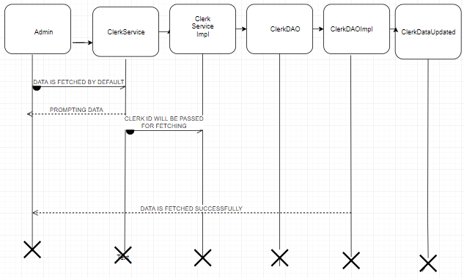

Business Rules
Business rules should be defined using the following attributes: -

- When the user clicks on the clerk tab, it should re-direct to clerk database.
- Clicking ‘id’ should fetch the details of the individual clerk.
- After the individual detail page is exited then it returns to fetching the complete database

UI Field Validations
Please refer to the below requirements for field level validations:

- All fields are mandatory except for alternate contact number.
- Username should be less than 30 chars. Password should have minimum 8 chars, no space & can contain special characters (ex.!,@,#,%,*,& etc.)
- The Email ID format must be checked. (For ex. test@testmail.com.)
- Phone Number must be of 10 digits’ length

Use case ‘Clerk Display All Details’

Use case attributes
Use Case Description:

This use case deals with the display of Clerk details. The ‘admin’ here shall be the operator of the system and will be keying in the required information into the system.

Scope:

- Clerk Display All Details

Actors:

- Admin – the operator

Trigger:

Click ‘Clerk’ button in the clerk home page and select Display All details from dropdown box.

Pre-Condition:

User being able to access the homepage & get redirected to the ‘Update Form’ page upon click of “Edit” link and delete the particular detail upon clicking the ‘Delete’ button..

Post Condition:
User is in the update page & submit details.

Flow of Events:
User at homepage → Click ‘Register’ link if new → Admin is in the enrollment page → Admin details are submitted and added onto the database.

Primary Scenario:
Only admin can make changes in the mandatory fields and the records are updated in the database.

Use Case Model
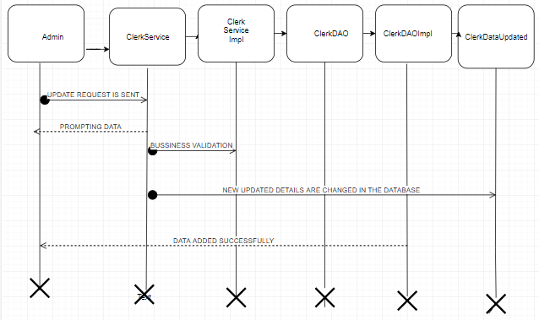

Business Rules

Business rules should be defined using the following attributes: -

- When the user clicks on the registration link, it should re-direct to updating form.
    - User needs to fill some of the basic attributes/fields whichever they think is required to be updated, as mentioned below in requirement: First Name, Last Name, Age, Gender, Contact Number, Alternate Contact number, Email ID, Password.
- Clicking ‘Update’ should validate the datatype constraints for each field
- Post-successful field level validation, save the information in the database
- Upon saving the information in the database, display the message ‘Your details are submitted successfully’.

UI Field Validations
Please refer to the below requirements for field level validations:

- All fields are mandatory except for alternate contact number.
- Username should be less than 30 chars. Password should have minimum 8 chars, no space & can contain special characters (ex.!,@,#,%,*,& etc.)
- The Email ID format must be checked. (For ex. test@testmail.com.)
- Phone Number must be of 10 digits’ length

Use case ‘Clerk Register’

Use case attributes
Use Case Description:

This use case deals with the capture of Clerk details. The ‘admin’ here shall be the operator of the system and will be keying in the required information into the system.

Scope:

- Clerk registration

Actors:

- Admin – the operator

Trigger:

Click ‘Add’ button in the ‘Clerk Registration’ page

Pre-Condition:

User being able to access the homepage & get redirected to the ‘Clerk Registration’ page upon click of “Add” link.

Post Condition:

User is in the enrollment page & submit details

Flow of Events:

User at homepage → Admin is in the enrollment page → Clerk details are submitted and added onto the database

Primary Scenario:
To add the details of a new clerk we press Add button which leads to ADD CLERK form which gives us two options i.e., after adding all the details we can either click on ‘add’ button to add in the database or ‘cancel’ button to clear the form.

Use Case Model
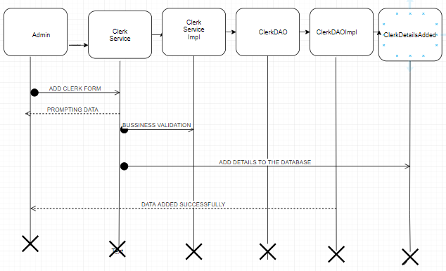

Business Rules

Business rules should be defined using the following attributes: -

- When the user clicks on the add link, it should re-direct to register form.
    - User needs to fill some of the basic attributes/fields as mentioned below in requirement: First Name, Last Name, Age, Gender, Contact Number, Alternate Contact number, Email ID, Password.
- Clicking ‘Add’ should validate the datatype constraints for each field
- Post-successful field level validation, save the information in the database
- Upon saving the information in the database, display the message ‘Your details are submitted successfully’.

UI Field Validations
Please refer to the below requirements for field level validations:

- All fields are mandatory except for alternate contact number.
- Username should be less than 30 chars. Password should have minimum 8 chars, no space & can contain special characters (ex.!,@,#,%,*,& etc.)
- Password and Confirm Password fields should be the same
- The Email ID format must be checked. (For ex. test@testmail.com.)
- Phone Number must be of 10 digits’ length

Use case ‘Doctor Display By Id’

Use case attributes
Use Case Description:

This use case deals with the fetching of doctor details. The ‘admin’ here shall be the operator of the system and will be keying in the required information into the system.

Scope:

- Doctor Display By Id

Actors:

- Admin – the operator

Trigger:

Click ‘Doctor’ button in the Home page post successful login.

Pre-Condition:

User being able to access the homepage .

Post Condition:

User is in the Doctor Tab and is able to view all the fields in the database.
Flow of Events:

User at homepage → Admin clicks at the Doctor Tab.

Primary Scenario:
As soon as the user clicks on the Doctor Tab all the details of the doctor database are fetched and once the doctor Id is clicked it leads to fetching the individual record of the Doctor displaying all the details of the Doctor.

Use Case Model
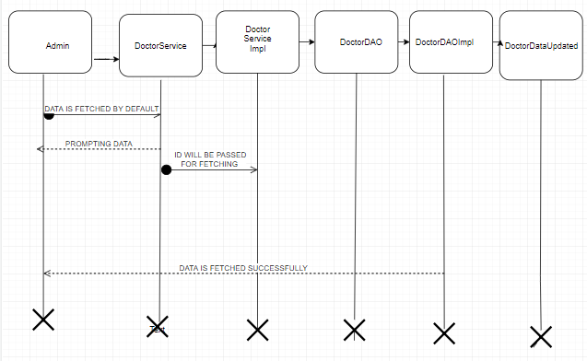

Business Rules

Business rules should be defined using the following attributes: -

- When the user clicks on the registration link, it should re-direct to registration form.
- When a particular ID is clicked then the complete record is fetched for the particular record..

UI Field Validations
Please refer to the below requirements for field level validations:

- All fields are mandatory except for alternate contact number.
- Username should be less than 30 chars. Password should have minimum 8 chars, no space & can contain special characters (ex.!,@,#,%,*,& etc.)
- Password and Confirm Password fields should be the same
- The Email ID format must be checked. (For ex. test@testmail.com.)
- Phone Number must be of 10 digits’ length

Use case ‘Doctor Display All Details’

Use case attributes
Use Case Description:

This use case deals with the update of Doctor details. The ‘admin’ here shall be the operator of the system and will be keying in the required information into the system.

Scope:

- Doctor Display All Details

Actors:

- Admin – the operator

Trigger:

Click ‘Doctor’ button in the home page and select Display All Details from the dropdown box.

Pre-Condition:

User being able to access the homepage & get redirected to the ‘Update Form’ page upon click of “Edit” link and delete the particular detail using the ‘Delete’ button.

Post Condition:

User is in the update page & submit details

Flow of Events:

User at homepage → Click ‘Register’ link if new → Admin is in the enrollment page → Admin details are submitted and added onto the database

Primary Scenario:
Only admin can make changes in the mandatory fields and the records are updated in the database.

Use Case Model
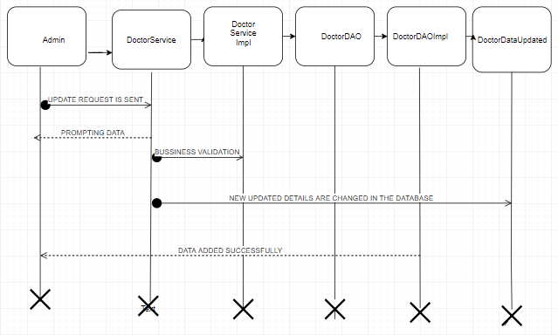

Business Rules

Business rules should be defined using the following attributes: -

- When the user clicks on the registration link, it should re-direct to updating form.
    - User needs to fill some of the basic attributes/fields whichever they think is required to be updated, as mentioned below in requirement: First Name, Last Name, Age, Gender, Contact Number, Alternate Contact number, Email ID, Password.
- Clicking ‘Update’ should validate the datatype constraints for each field
- Post-successful field level validation, save the information in the database
- Upon saving the information in the database, display the message ‘Your details are submitted successfully’.

UI Field Validations
Please refer to the below requirements for field level validations:

- All fields are mandatory except for alternate contact number.
- Username should be less than 30 chars. Password should have minimum 8 chars, no space & can contain special characters (ex.!,@,#,%,*,& etc.)
- The Email ID format must be checked. (For ex. test@testmail.com.)
- Phone Number must be of 10 digits’ length

Use case ‘Doctor Register’

Use case attributes
Use Case Description:

This use case deals with the capture of Doctor details. The ‘admin’ here shall be the operator of the system and will be keying in the required information into the system.

Scope:

- Doctor registration

Actors:

- Admin – the operator

Trigger:

Click ‘Add’ button in the ‘Doctor Registration’ page

Pre-Condition:

User being able to access the homepage & get redirected to the ‘Doctor Registration’ page upon click of “Add” link.

Post Condition:

User is in the enrollment page & submit details

Flow of Events:

User at homepage → Admin is in the enrollment page → Doctor details are submitted and added onto the database

Primary Scenario:
To add the details of a new clerk we press Add button which leads to ADD DOCTOR form which gives us two options i.e., after adding all the details we can either click on ‘add’ button to add in the database or ‘cancel’ button to clear the form.

Use Case Model
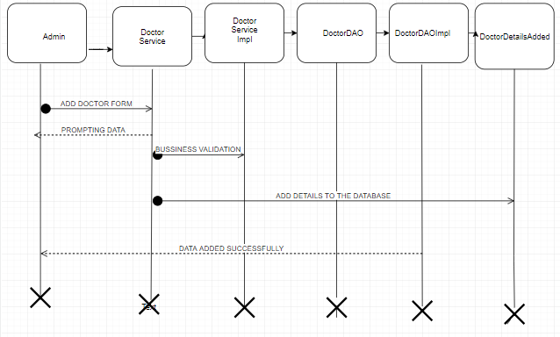

Business Rules

Business rules should be defined using the following attributes: -

- When the user clicks on the add link, it should re-direct to register form.
    - User needs to fill some of the basic attributes/fields as mentioned below in requirement: First Name, Last Name, Age, Gender, Contact Number, Alternate Contact number, Email ID, Password ,etc.
- Clicking ‘Add’ should validate the datatype constraints for each field
- Post-successful field level validation, save the information in the database
- Upon saving the information in the database, display the message ‘Your details are submitted successfully’.

UI Field Validations
Please refer to the below requirements for field level validations:

- All fields are mandatory except for alternate contact number.
- Username should be less than 30 chars. Password should have minimum 8 chars, no space & can contain special characters (ex.!,@,#,%,*,& etc.)
- Password and Confirm Password fields should be the same
- The Email ID format must be checked. (For ex. test@testmail.com.)
Phone Number must be of 10 digits’ length

Use case ‘Patient Display By Id’

Use case attributes
Use Case Description:

This use case deals with the fetching of patient details. The ‘admin’ here shall be the operator of the system and will be keying in the required information into the system.

Scope:

- Patient Display By Id

Actors:

- Admin – the operator

Trigger:

Click ‘Patient’ button in the Home page post successful login.

Pre-Condition:

User being able to access the homepage .

Post Condition:

User is in the Patient Tab and is able to view all the fields in the database.
Flow of Events:

User at homepage → Admin clicks at the Patient Tab.

Primary Scenario:
As soon as the user clicks on the Patient Tab all the details of the Patient database are fetched and once the patient Id is clicked it leads to fetching the individual record of the Patient displaying all the details of the Patient.

Use Case Model
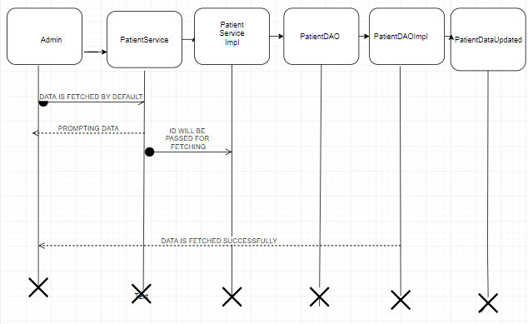

Business Rules

Business rules should be defined using the following attributes: -

- When the user clicks on the registration link, it should re-direct to registration form.
- When a particular ID is clicked then the complete record is fetched for the particular record.

UI Field Validations
Please refer to the below requirements for field level validations:

- All fields are mandatory except for alternate contact number.
- Username should be less than 30 chars. Password should have minimum 8 chars, no space & can contain special characters (ex.!,@,#,%,*,& etc.)
- Password and Confirm Password fields should be the same
- The Email ID format must be checked. (For ex. test@testmail.com.)
- Phone Number must be of 10 digits’ length

Use case ‘Patient Display All Details’

Use case attributes
Use Case Description:

This use case deals with the update of Patient details. The ‘admin’ here shall be the operator of the system and will be keying in the required information into the system.

Scope:

- Patient Display All Details

Actors:

- Admin – the operator

Trigger:

Click ‘patient’ button in the home page and select Display All Details from the dropdown box.

Pre-Condition:

User being able to access the homepage & get redirected to the ‘Update Form’ page upon click of “Edit” link and delete the particular detail using the ‘Delete’ button.

Post Condition:

User is in the update page & submit details

Flow of Events:

User at homepage → Click ‘Register’ link if new → Admin is in the enrollment page → Admin details are submitted and added onto the database

Primary Scenario:
Only admin can make changes in the mandatory fields and the records are updated in the database.

Use Case Model
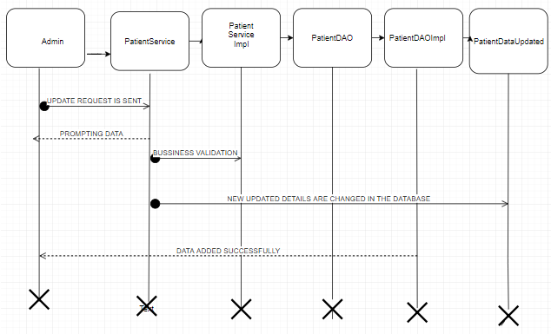

Business Rules

Business rules should be defined using the following attributes: -

- When the user clicks on the registration link, it should re-direct to updating form.
    - User needs to fill some of the basic attributes/fields whichever they think is required to be updated, as mentioned below in requirement: First Name, Last Name, Age, Gender, Contact Number, Alternate Contact number, Email ID, Password.
- Clicking ‘Update’ should validate the datatype constraints for each field
- Post-successful field level validation, save the information in the database
- Upon saving the information in the database, display the message ‘Your details are submitted successfully’.

UI Field Validations
Please refer to the below requirements for field level validations:

- All fields are mandatory except for alternate contact number.
- Username should be less than 30 chars. Password should have minimum 8 chars, no space & can contain special characters (ex.!,@,#,%,*,& etc.)
- The Email ID format must be checked. (For ex. test@testmail.com.)
- Phone Number must be of 10 digits’ length

Use case ‘Patient Register’

Use case attributes
Use Case Description:

This use case deals with the capture of Patient details. The ‘admin’ here shall be the operator of the system and will be keying in the required information into the system.

Scope:

- Patient registration

Actors:

- Admin – the operator

Trigger:

Click ‘Add’ button in the ‘Patient Registration’ page

Pre-Condition:

User being able to access the homepage & get redirected to the ‘Patient Registration’ page upon click of “Add” link.

Post Condition:

User is in the enrollment page & submit details

Flow of Events:

User at homepage → Admin is in the enrollment page → Patient details are submitted and added onto the database

Primary Scenario:
To add the details of a new clerk we press Add button which leads to ADD PATIENT form which gives us two options i.e., after adding all the details we can either click on ‘add’ button to add in the database or ‘cancel’ button to clear the form.

Use Case Model
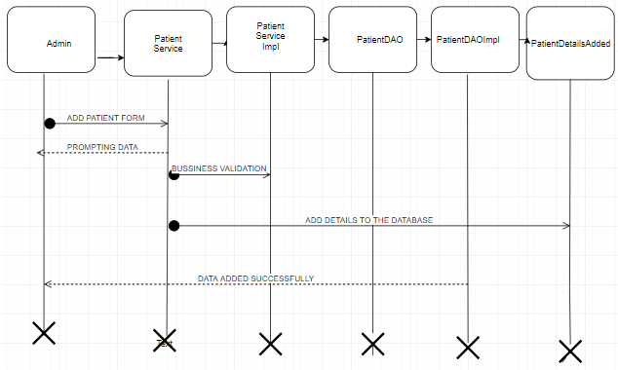

Business Rules

Business rules should be defined using the following attributes: -

- When the user clicks on the add link, it should re-direct to register form.
    - User needs to fill some of the basic attributes/fields as mentioned below in requirement: First Name, Last Name, Age, Gender, Contact Number, Alternate Contact number, Email ID, Password ,etc.
- Clicking ‘Add’ should validate the datatype constraints for each field
- Post-successful field level validation, save the information in the database
- Upon saving the information in the database, display the message ‘Your details are submitted successfully’.

UI Field Validations
Please refer to the below requirements for field level validations:

- All fields are mandatory except for alternate contact number.
- Username should be less than 30 chars. Password should have minimum 8 chars, no space & can contain special characters (ex.!,@,#,%,*,& etc.)
- Password and Confirm Password fields should be the same
- The Email ID format must be checked. (For ex. test@testmail.com.)
Phone Number must be of 10 digits’ length.

Use case ‘Medicine Display By Id’

Use case attributes
Use Case Description:

This use case deals with the fetching of Medicine details. The ‘admin’ here shall be the operator of the system and will be keying in the required information into the system.

Scope:

- Medicine Display By Id

Actors:

- Admin – the operator

Trigger:

Click ‘Medicine’ button in the Home page post successful login.

Pre-Condition:

User being able to access the homepage.

Post Condition:

User is in the Medicine Tab and is able to view all the fields in the database.
Flow of Events:

User at homepage → Admin clicks at the MedicineTab.

Primary Scenario:
As soon as the user clicks on the Medicine Tab all the details of the Medicine database are fetched and once the doctor Id is clicked it leads to fetching the individual record of the medicine displaying all the details of the medicine.

Use Case Model
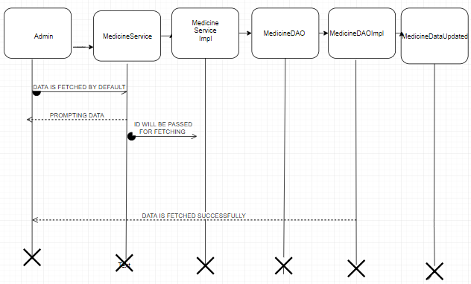

Business Rules

Business rules should be defined using the following attributes: -

- When the user clicks on the registration link, it should re-direct to registration form.
- When a particular ID is clicked then the complete record is fetched for the particular record.

UI Field Validations
Please refer to the below requirements for field level validations:

- All fields are mandatory except for alternate contact number.
- Username should be less than 30 chars. Password should have minimum 8 chars, no space & can contain special characters (ex.!,@,#,%,*,& etc.)
- Password and Confirm Password fields should be the same
- The Email ID format must be checked. (For ex. test@testmail.com.)
- Phone Number must be of 10 digits’ length

Use case ‘Medicine Display All Details’

Use case attributes
Use Case Description:

This use case deals with the update of Medicine details. The ‘admin’ here shall be the operator of the system and will be keying in the required information into the system.

Scope:

- Medicine Display All Details

Actors:

- Admin – the operator

Trigger:

Click ‘Medicine’ button in the home page and select Display All details from the dropdown box.

Pre-Condition:

User being able to access the homepage & get redirected to the ‘Update Form’ page upon click of “Edit” link and delete the particular detail using ‘delete’ button..

Post Condition:

User is in the update page & submit details

Flow of Events:

User at homepage → Click ‘Register’ link if new → Admin is in the enrollment page → Admin details are submitted and added onto the database

Primary Scenario:
Only admin can make changes in the mandatory fields and the records are updated in the database.

Use Case Model
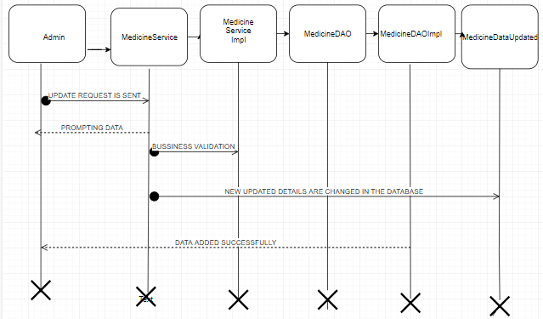

Business Rules

Business rules should be defined using the following attributes: -

- When the user clicks on the registration link, it should re-direct to updating form.
- User needs to fill some of the basic attributes/fields whichever they think is required to be updated, Clicking ‘Update’ should validate the datatype constraints for each field
- Post-successful field level validation, save the information in the database
- Upon saving the information in the database, display the message ‘Your details are submitted successfully’.

UI Field Validations
Please refer to the below requirements for field level validations:

- All fields are mandatory except for alternate contact number.
- Username should be less than 30 chars. Password should have minimum 8 chars, no space & can contain special characters (ex.!,@,#,%,*,& etc.)
- Password and Confirm Password fields should be the same
- The Email ID format must be checked. (For ex. test@testmail.com.)
- Phone Number must be of 10 digits’ length

Use case ‘Medicine Register’

Use case attributes
Use Case Description:

This use case deals with the capture of Medicine details. The ‘admin’ here shall be the operator of the system and will be keying in the required information into the system.

Scope:

- Medicine registration

Actors:

- Admin – the operator

Trigger:

Click ‘Add’ button in the ‘Medicine Registration’ page

Pre-Condition:

User being able to access the homepage & get redirected to the ‘Medicine Registration’ page upon click of “Add” link.

Post Condition:

User is in the enrollment page & submit details

Flow of Events:

User at homepage → Admin is in the enrollment page → Medicine details are submitted and added onto the database

Primary Scenario:
To add the details of a new clerk we press Add button which leads to ADD MEDICINE form which gives us two options i.e., after adding all the details we can either click on ‘add’ button to add in the database or ‘cancel’ button to clear the form.

Use Case Model
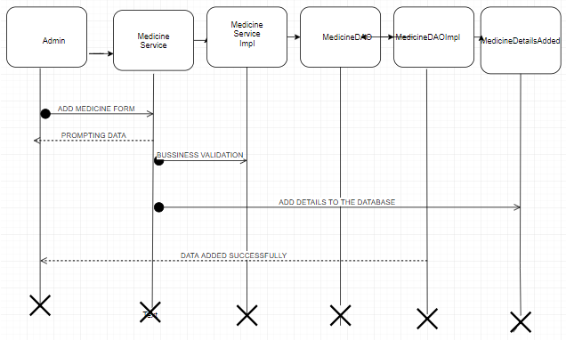

Business Rules

Business rules should be defined using the following attributes: -

- When the user clicks on the add link, it should re-direct to register form.
    - User needs to fill some of the details required.
- Clicking ‘Add’ should validate the datatype constraints for each field
- Post-successful field level validation, save the information in the database
- Upon saving the information in the database, display the message ‘Your details are submitted successfully’.

UI Field Validations
Please refer to the below requirements for field level validations:

- All fields are mandatory except for alternate contact number.
- Username should be less than 30 chars. Password should have minimum 8 chars, no space & can contain special characters (ex.!,@,#,%,*,& etc.)
- Password and Confirm Password fields should be the same
- The Email ID format must be checked. (For ex. test@testmail.com.)
- Phone Number must be of 10 digits’ length

Use case ‘Create Prescription and Bill’

Use case attributes
Use Case Description:

This use case deals with the fetching of Prescription details. The ‘admin’ here shall be the operator of the system and will be keying in the required information into the system.

Scope:

- Prescription creation and generation of Bill.

Actors:

- Admin – the operator

Trigger:

Click ‘Patient’ button in the Home page and select ‘create prescription and bill’ from the dropdown box.

Pre-Condition:

User being able to access the homepage.

Post Condition:

User is in the Prescription Tab and is able to view all the fields in the database.
Flow of Events:

User at homepage → Admin clicks at the ‘create prescription and bill’ of the patient button → select patient id, doctor id, date, medicine id, quantity (click add more medicine to add medicine) and select create bill → select prescription id and select ‘generate bill’ button → bill detail is displayed.

Primary Scenario:
As soon as the user clicks on the Prescription Tab all the details of the Prescription database are fetched and once the doctor Id is clicked it leads to fetching the individual record of the prescription displaying all the details of the prescription.

Use Case Model
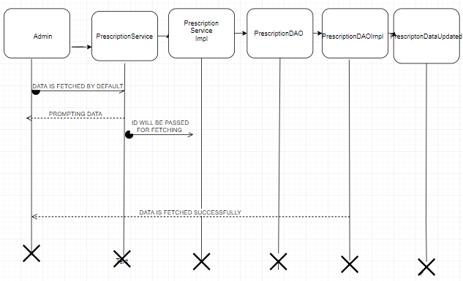

Business Rules

Business rules should be defined using the following attributes: -

- When the user clicks on the registration link, it should re-direct to registration form.
- When a particular ID is clicked then the complete record is fetched for the particular record.

UI Field Validations
Please refer to the below requirements for field level validations:

- All fields are mandatory except for alternate contact number.
- Username should be less than 30 chars. Password should have minimum 8 chars, no space & can contain special characters (ex.!,@,#,%,*,& etc.)
- Password and Confirm Password fields should be the same
- The Email ID format must be checked. (For ex. test@testmail.com.)
- Phone Number must be of 10 digits’ length

Change Log
Version Number | Changes Made
V1.0 | Initial baseline created on 06 June, 2019 by Amrutha CY
V1.1 | <Please refer the configuration control tool / change item status form if the details of changes are maintained separately. If not, the template given below needs to be followed>
V1.1 | Section No. | Changed By | Effective Date | Changes Effected

